

APPLICATION SYSTEM DOCUMENTATION COMPILATION

KOD SUMBER SISTEM
PENGURUSAN SISTEM GYM

VERSI:1.0
TARIKH DILULUSKAN:25/01/2026
MUHAMMAD NAZHAN BIN ZULKIFLI

DOKUMENTASI KOD SUMBER BAGI SISTEM PENGURUSAN GYM
Versi | Tarikh Diluluskan | Pemilik
1.0 | 25/1/2025 | nazhan

- Tujuan
Dokumentasi ini bertujuan sebagai keperluan untuk mengurus kod sumber, memastikan kawalan versi, mengurus dokumen berkaitan dan mengawal risiko kehilangan kod sumber.

- Maklumat Asas
  - Sistem

• A software system based on the Windows 7 Computer Coding
Platform.
• Local Web Development System using Sublime Text as the
main editor.
• Database Management and Referencing System through
XAMPP (Apache &amp; MySQL).
• Pengujian berdasarkan browser, Google Chrome.
•System name or title: CODEMATRIX
• System code: STX7

SOFTWARE/HARDWARE REQUIREMENT
• Perisian penyunting kod / editor teks seperti Notepad, Notepad++,
Sublime Text untuk pengubahsuaian.
• Membuka Chrome/Sebarang Browser untuk lihat paparan

  - Rujukan Projek
w3school: How To Create a BMI Calculator Rekaan Calculator BMI
MDN Web Docs: Sending Form Data penghantaran maklumat data
Dribbble: Gym Dashboard UI Design Ideas rekabentuk UI

  - Hubungi
MUHAMMAD NAZHAN BIN ZULKIFLI
08-XXXX-XXXXX
MAIL@FAKEMAIL.COM

3. Kod Sumber
Skrin pertama:
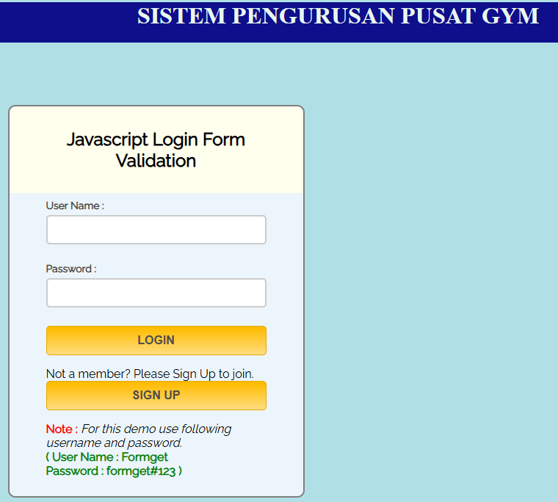
Kod Sumber: Login2.html
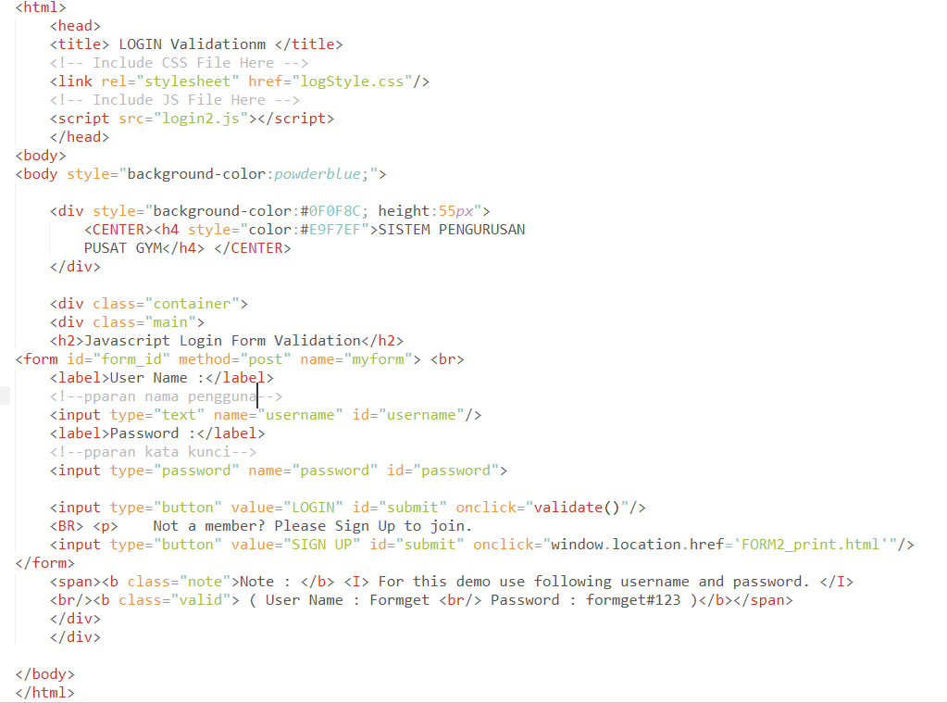

Skrin Kedua:
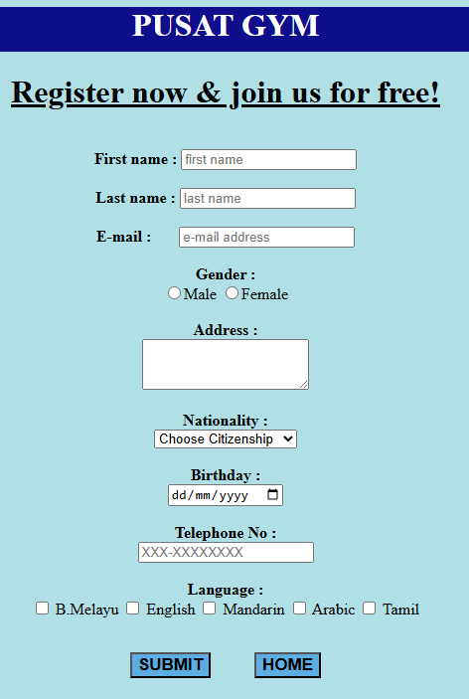
Kod Sumber: FORM2_print.html
<!DOCTYPE html>
<html>
<head>
<title>Web Form</title>
/*tajuk*/
<!--link rel='stylesheet' type='text/css' href=''/>
<link href='http://fonts.googleapis.com/css?family=Lobster' rel='stylesheet' type='text/css'-->
<script src="https://ajax.googleapis.com/ajax/libs/jquery/2.1.1/jquery.min.js"> </script>
<!--script src="Scripts/jquery-1.4.1.js" type="text/javascript"></script-->
<!--script src="Scripts/jquery-1.4.1-vsdoc.js" type="text/javascript"></script-->
<script >
function display() {
DispWin = window.open('','NewWin','toolbar=yes,status=yes,width=700,height=500')
var items=document.getElementsByName('langz');
var selectItems="";
for(var i=0; i<items.length; i++){
if(items[i].type=='checkbox' && items[i].checked==true)
selectItems+= " ~ " + items[i].value;
}

message = "<b>THANK YOU!</b><BR> Now you can enjoy membership benefits. Here are your details upon registration:- <pre>" ;
message += "<ul><li>Fisrst NAME: <b>" + document.answer.firstName.value + "</b>";
message += "<li> Last Name : <b>" + document.answer.lastName.value + "</b>";
message += "<li> E-mail : <b>" + document.answer.email.value + "</b>";
message += "<li> Gender : <b>" + document.answer.gen.value + "</b>";
message += "<li> Address : <b>" + document.answer.addr.value + "</b>";
message += "<li> Nationality : <b>" + document.answer.nation.value + "</b>";
message += "<li> Birthday : <b>" + document.answer.bday.value + "</b>";
message += "<li> Contact no. : <b>" + document.answer.telno.value + "</b>";
message += "<li> Language :" + (selectItems) + "</ul>" + "<br>" +
'<br> <input type="button" value="Print" onclick="window.print()" />' ;
DispWin.document.write(message);
}
</script> </head>
<body>
<body style="background-color:powderblue;"> <center>
<div style="background-color:#0F0F8C ;height:45px">

<CENTER><h1 style="color:white">PUSAT GYM</h1> </CENTER>
</div>

<div id="header"><h1><u>Register now & join us for free!</u></h1></div>
<br><div id="wrapper">
<form name="answer" action=" " method="post" id="answers" autofocus>
<b>First name :</b> <input type="text" name="firstName" id="fname" placeholder="first name"><br/>
<br><b>Last name :</b> <input type="text" name="lastName" placeholder="last name" id="lname"> <br/>
<br><b>E-mail :</b> &nbsp; &nbsp; &nbsp;
<input type="email" name="email" placeholder="e-mail address" id="mail"> <br/><br/>
<b>Gender :</b><br>
<input type="radio" name="gen" value="male">Male
<input type="radio" name="gen" value="female">Female<br/>
<br><b>Address :</b><br/>
<textarea name="addr" rows="3" placeholder="your home address.."> </textarea>
<br><br> <b>Nationality :</b> <br>
<select name="nation" id="nations" >
<option value="default" checked>Choose Citizenship</option>
<option value="Citizen">Citizen </option>
<option value="Permanent Resident">Permanent Resident </option>
<option value="Non_Citizen">Non-Citizen </option></select><br>
<br><b> Birthday : </b><br>
<input type="date" name="bday" format="dd-mm-yyyy"> <br/>
<br><b> Telephone No : </b><br>
<input type="password" name="telno" id="telno" maxlength="10" placeholder="XXX-XXXXXXXX" >
<br/>
<div id="inputx" name="choices" class="choice" >
<br><b>Language :</b><br>
<input class="choice" type="checkbox" name="langz" value="B.MELAYU" > B.Melayu
<input class="choice" type="checkbox" name="langz" value="ENGLISH" > English
<input class="choice" type="checkbox" name="langz" value="MANDARIN" > Mandarin
<input class="choice" type="checkbox" name="langz" value="ARABIC" > Arabic
<input class="choice" type="checkbox" name="langz" value="TAMIL" > Tamil
</div>
<br><p>
/*jenis suatu input*/ <input type="submit" id="submit" value="SUBMIT" onclick="display()" style="font-weight:bold; font-size:17px; width:auto; background-color:#5DADE2">
&nbsp; &nbsp; &nbsp; &nbsp; &nbsp;
<input type="reset" id="submit" value="HOME" onclick="window.location.href='Login2.html'" style="font-weight:bold; font-size:17px; width:auto; background-color:#5DADE2" />
</form>
/* penutupan tag borang*/
</div>
</body></html>

Skrin Ketiga:
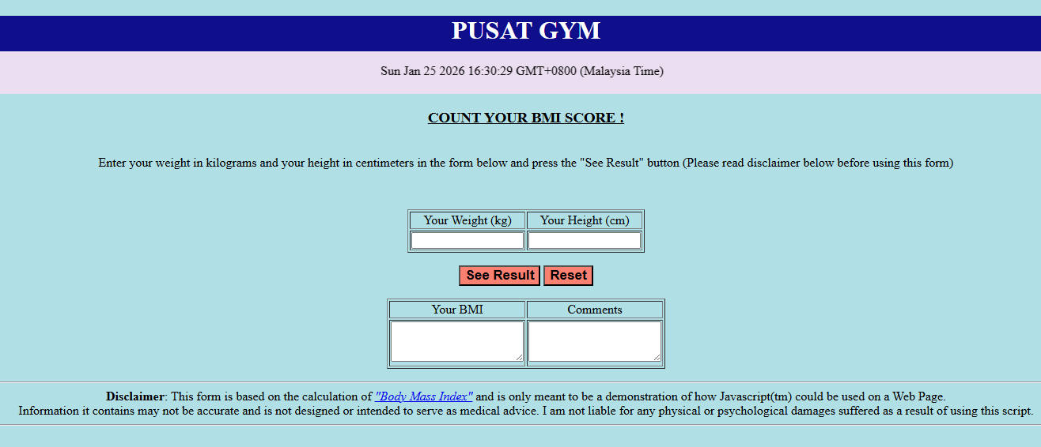
Kod Sumber: BMI_kira.html
<!DOCTYPE html>
<html>
<head>
<title> </title>
</head>
<body>
<body style="background-color:powderblue;">
<div style="background-color:#0F0F8C ;height:45px">
<CENTER><h1 style="color:white">PUSAT GYM</h1> </CENTER>
</div>
<div header style="background-color:#EBDEF0;" ><center>

<marquee>
<p id="demo"></p>
</marquee>

</div>
<CENTER><H3><U> COUNT YOUR BMI SCORE ! </U></H3></CENTER>

<center><br>
Enter your weight in kilograms and your height in centimeters in the form below and press the "See Result" button (Please read disclaimer below before using this form)
<P> <br>
<FORM NAME="BMI" method=POST> /*nama borang*/
<TABLE border=1>
<TR>
<TD><DIV ALIGN=CENTER> Your Weight (kg)</DIV></TD>
<TD><DIV ALIGN=CENTER> Your Height (cm)</DIV></TD>

</TR>
<TR>
<TD><INPUT TYPE=TEXT NAME=weight SIZE=15 onFocus="this.form.weight.value=''" maxlength=3></TD>
<TD><INPUT TYPE=TEXT NAME=height SIZE=15 onFocus="this.form.height.value=''" maxlength=3></TD>
</TR>
</TABLE>

<P>
<INPUT TYPE="button" VALUE="See Result" onClick="computeform(this.form)" style="font-weight:bold; font-size:17px; width:auto; background-color:salmon" >
<INPUT TYPE="reset" VALUE="Reset" onClick="ClearForm(this.form)" style="font-weight:bold; font-size:17px; width:auto; background-color:salmon" >

<!--/FORM-->

<TABLE border=1>
<TR>
<TD><DIV ALIGN=CENTER> Your BMI </DIV></TD>
<TD ><DIV ALIGN=CENTER> Comments </DIV></TD>
</TR>
<TR>

<TD rowspan="2"><textarea rows="3" NAME=bmi SIZE=8 readonly> </textarea></TD>
<TD rowspan="2" ><textarea rows="3" NAME=my_comment size=55 readonly> </textarea></TD>

</TABLE>
</FORM>

<P><HR>
<B>Disclaimer</B>: This form is based on the calculation of
<A HREF="http://phaster.com/unpretentious/bmi.html"><I>"Body Mass Index"</I></A>
and is only meant to be a demonstration of how Javascript(tm) could be used
on a Web Page.
<br> /*break – membuat jarakan ruang kosong*/
Information it contains may not be accurate and is not designed or intended to serve as medical advice. I am not liable for any physical or psychological damages suffered as a result of using this script.

<!--p>This free script provided by
<a href="http://javascriptkit.com">JavaScript
Kit</a></p-->
<hr>

<SCRIPT LANGUAGE="JAVASCRIPT">
<!-- hide this script tag's contents from old browsers

//Body Mass calculator- by John Scott (johnscott03@yahoo.com)
//Visit JavaScript Kit (http://javascriptkit.com) for script
//Credit must stay intact for use

var d = new Date();
document.getElementById("demo").innerHTML = d;
/*kefungsian membuat elemen dalam borang*/
function ClearForm(form){

form.weight.value = "";
form.height.value = "";
form.bmi.value = "";
form.my_comment.value = "";

}
/*kefungsian bmi*/
function bmi(weight, height) {

bmindx=weight/eval(height*height);
return bmindx;
}

/*pengesahan/semakan borang*/
function checkform(form) {

if (form.weight.value==null||form.weight.value.length==0 || form.height.value==null||form.height.value.length==0){
alert("\nPlease complete the form first");
return false;
}

else if (parseFloat(form.height.value) <= 0||
parseFloat(form.height.value) >=500||
parseFloat(form.weight.value) <= 0||
parseFloat(form.weight.value) >=500){
alert("\nReally know what you're doing? \nPlease enter values again. \nWeight in kilos and \nheight in cm");
ClearForm(form);
return false;
}
return true;

}

function computeform(form) {

if (checkform(form)) {

yourbmi=Math.round(bmi(form.weight.value, form.height.value/100));
form.bmi.value=yourbmi;

if (yourbmi >40) {
form.my_comment.value="You are grossly obese, consult your physician!";
}

else if (yourbmi >30 && yourbmi <=40) {
form.my_comment.value="Umm... You are obese, want some liposuction?";
}

else if (yourbmi >27 && yourbmi <=30) {
form.my_comment.value="You are very fat, do something before it's too late";
}

else if (yourbmi >22 && yourbmi <=27) {
form.my_comment.value="You are fat, need dieting and exercise";
}

else if (yourbmi >=21 && yourbmi <=22) {
form.my_comment.value="I envy you. Keep it up!!";
}

else if (yourbmi >=18 && yourbmi <21) {
form.my_comment.value="You are thin, eat more.";
}

else if (yourbmi >=16 && yourbmi <18) {
form.my_comment.value="You are starving. Go Find some food!";
}

else if (yourbmi <16) {
form.my_comment.value="You're grossly undernourished, need hospitalization ";
}

}
return;
}
// -- done hiding from old browsers -->
</SCRIPT>
</body>
</html>

